Power BI Assignment 1 - Data Transformation, Data Modeling
By Aravind S

1.Import “List of Orders.csv” into Power BI.
Open “List of Orders” in Power Query Editor by clicking on ‘Transform’.
Import “Order Details.csv” and “Sales target.csv” into Power Query Editor.
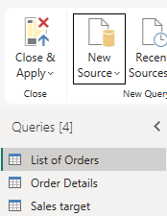
2. Restrict the "List of Orders" table to only the first 500 rows.
Using Remove duplicate to remove null value
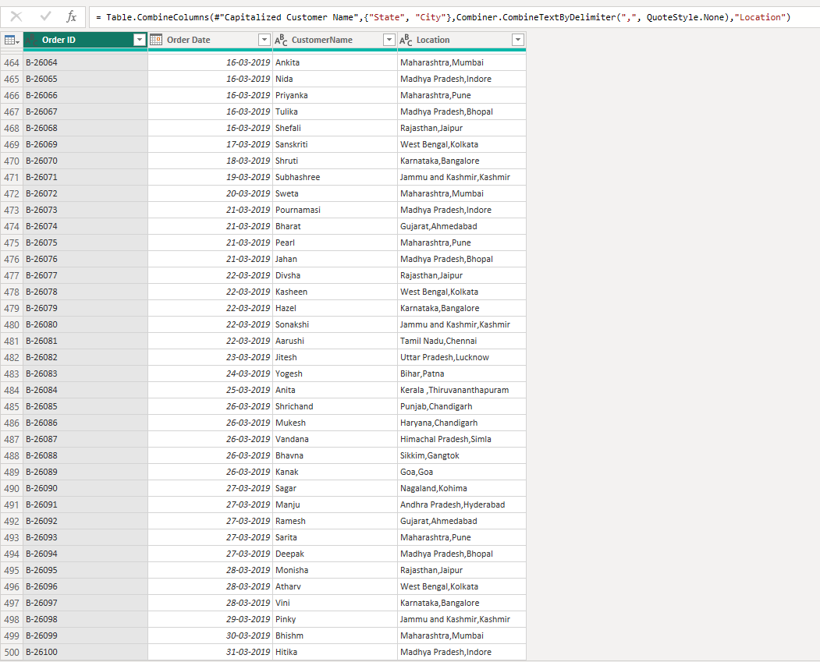

3.Ensure the “Order Date” column in the “List of Orders” table is set to data type 'Date'.
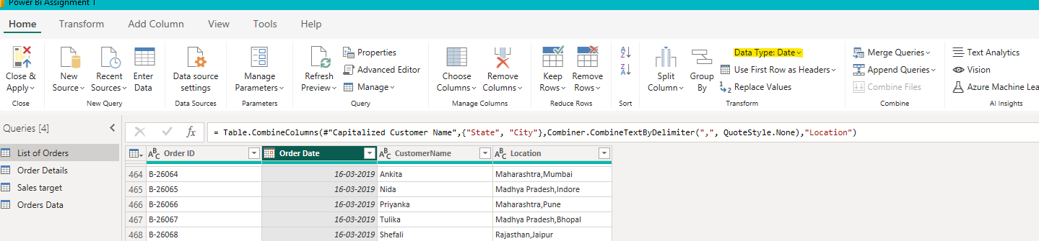
4.Change the data type of “Amount” and “Target” columns to ‘Fixed Decimal Number’.
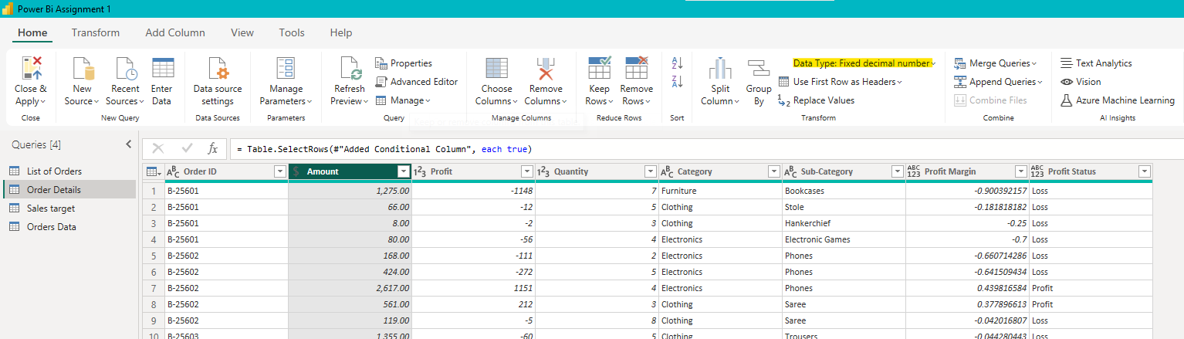
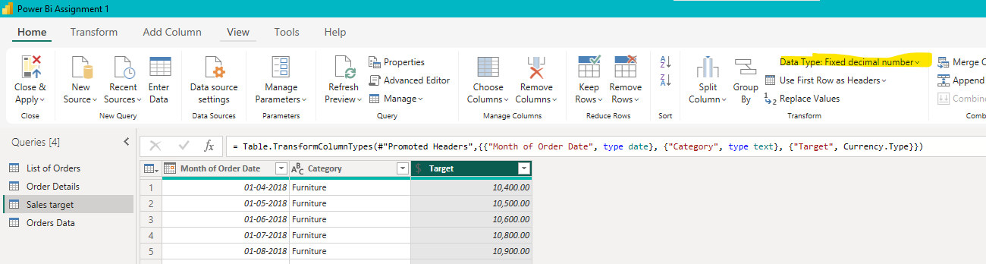

5.Format the "CustomerName" column into proper case, ensuring consistent capitalization for each word.
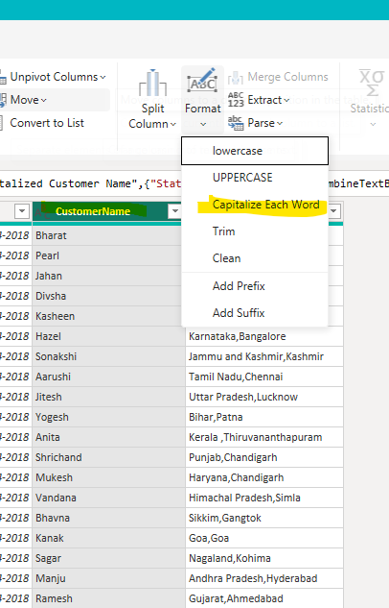

6.Merge the "State" and "City" columns to create a new column named "Location" in the format ‘City, State’.
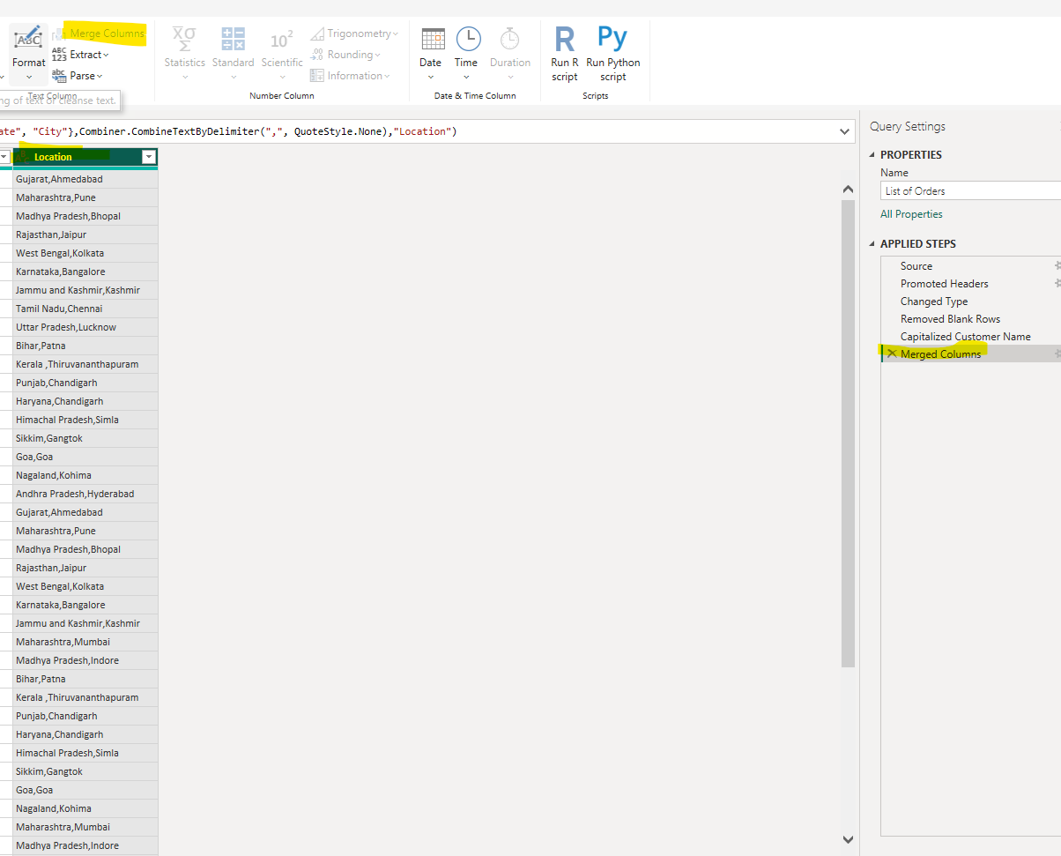

7. Create a new custom column named "Profit Margin" as the percentage of "Profit" divided by "Amount".
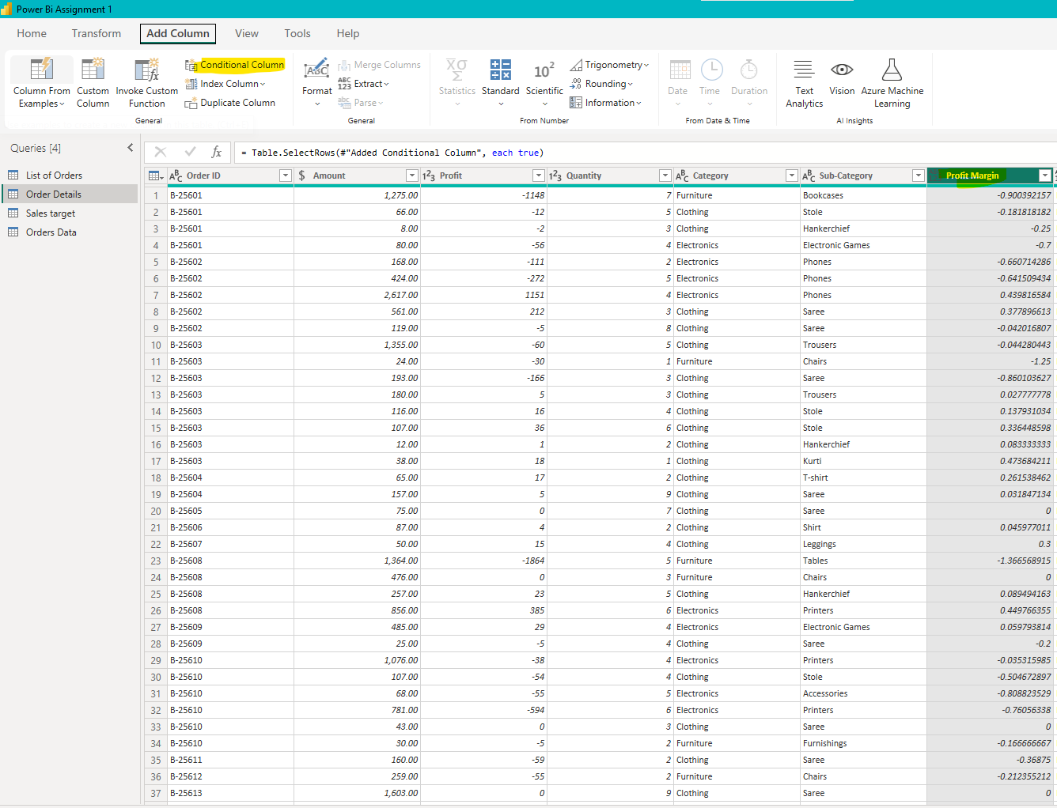

8.Add a new conditional column named "Profit Status" based on the values in the "Profit" column. The conditions are as follows: if the profit is less than 0, the label should be "Loss"; if the profit equals 0, the label should be "Break-Even"; and if the profit is greater than 0, the label should be "Profit".
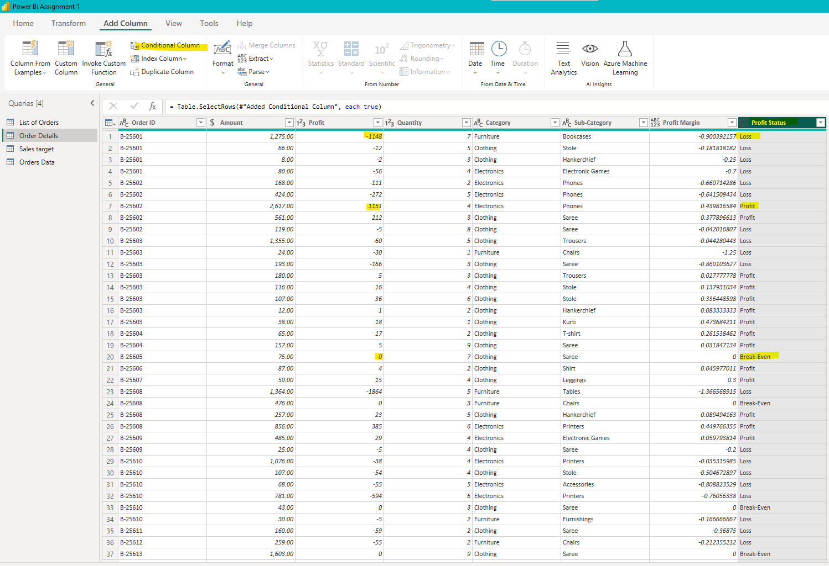

9.Merge the "List of Orders" and "Order Details" tables into a new single table named "Orders Data" based on the "Order ID" relationship.
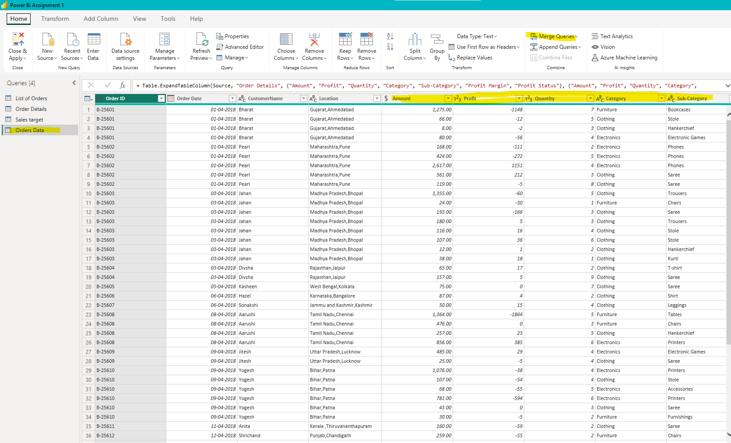
10. Identify missing values in the data and determine a strategy to address them.
I use the filter to find missing values but there is no Missing values in the table
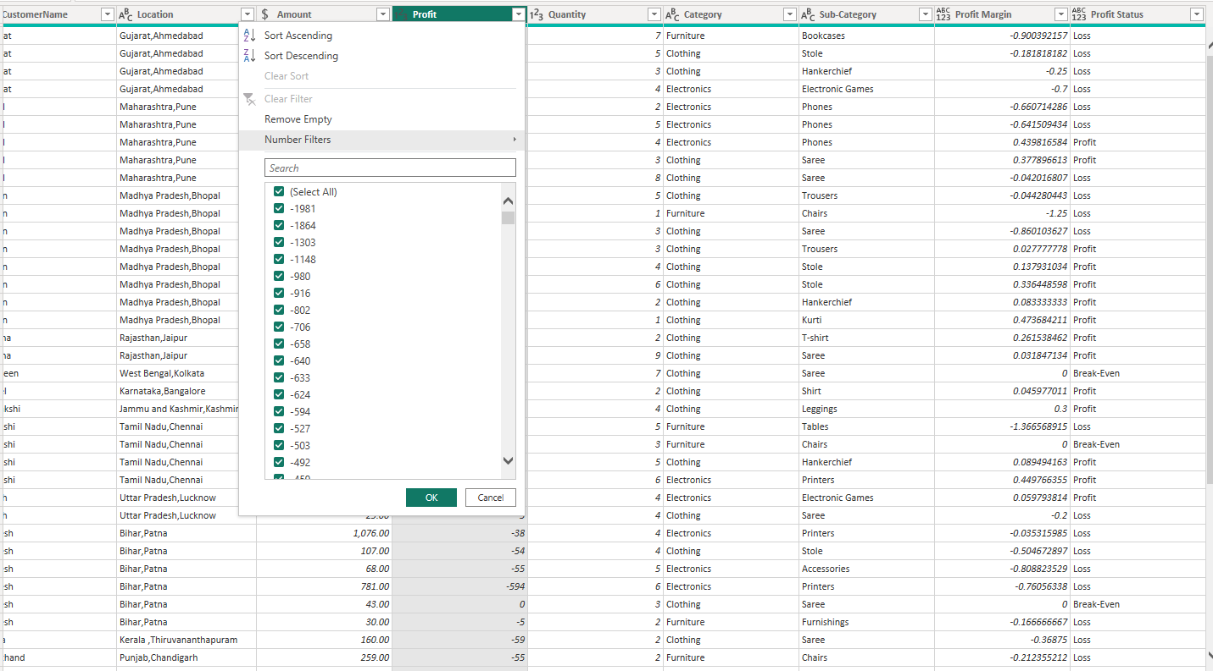

11.Check for duplicate rows and define a strategy to handle duplicates.
There are no duplicate values We can use Group by > Count to identify the duplicate values
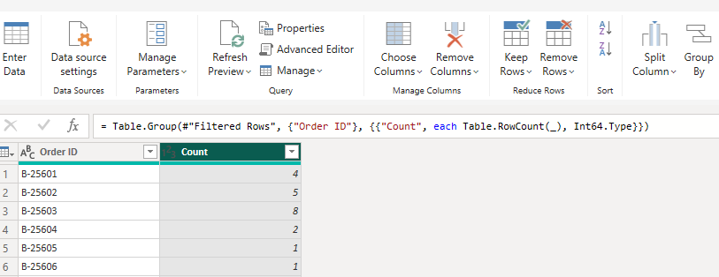
12.Sort the orders by Order Date in descending order to analyze recent trends.
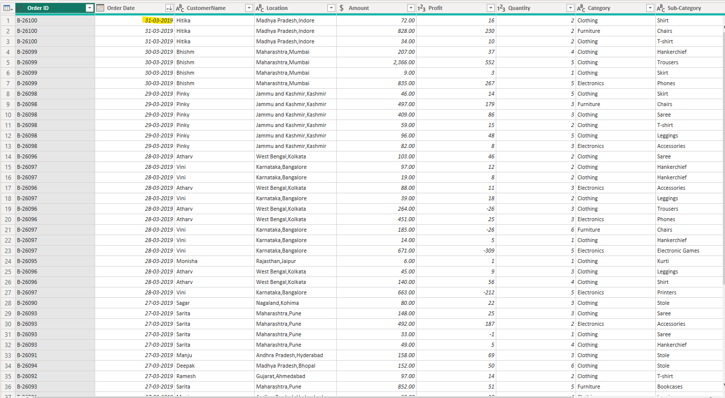

13.Filter the orders to focus only on a specific state (e.g., Tamil Nadu) for regional analysis.
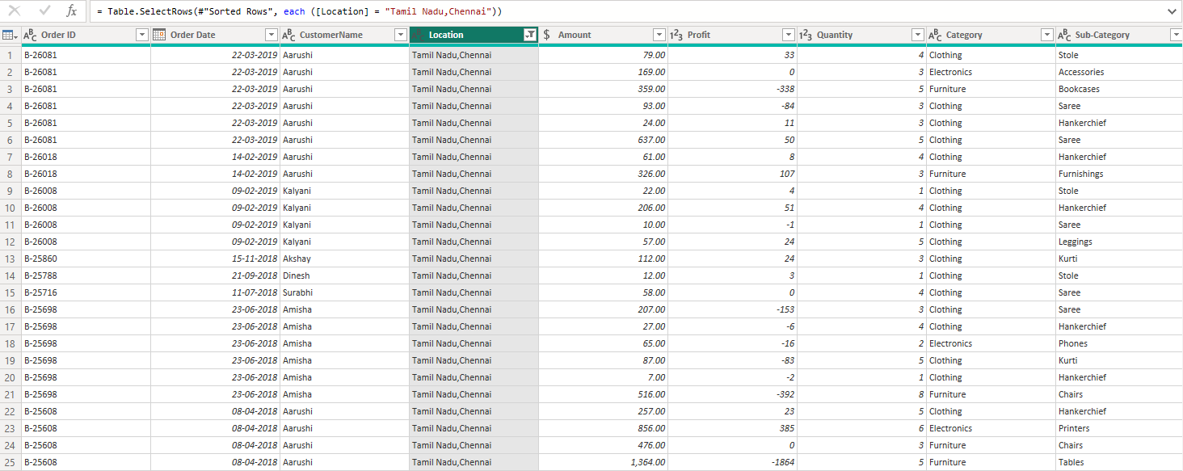

14.Duplicate the “Order Details” table and calculate the count of each Order ID, average profit by Category or total amount by Sub-Category.

Duplicate the “Order Details” table and calculate the count of each Order ID
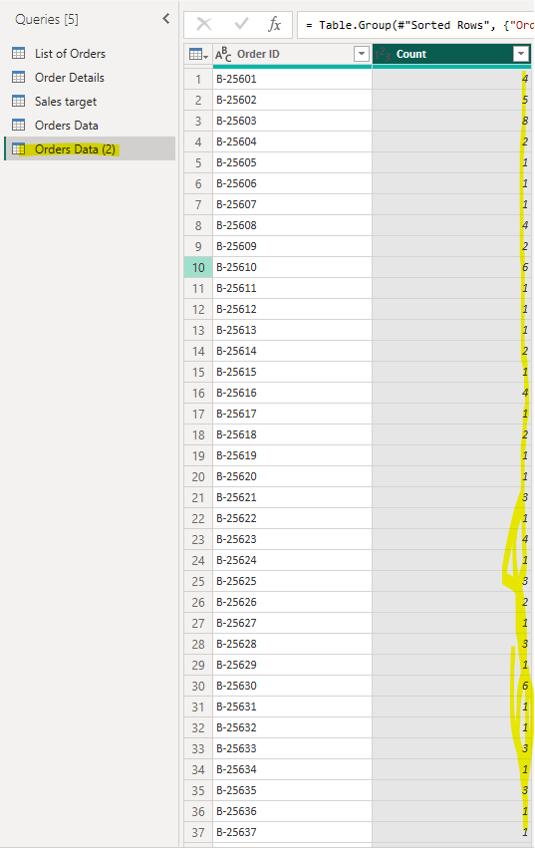
Average profit by Category
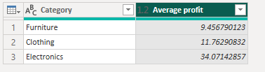
Total amount by Sub-Category.
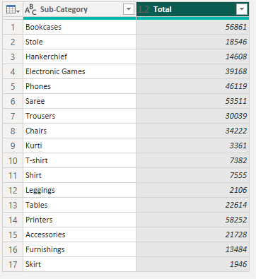

15.Duplicate the “Sales Target” table and aggregate the total target amount by Month of Order Date.
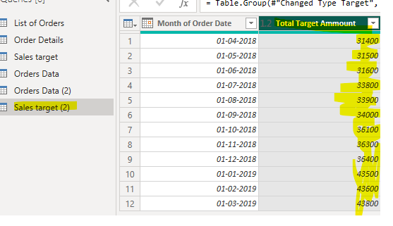
16.Establish a relationship between the “List of Orders” and “Order Details” tables using the ‘Order ID’ column.
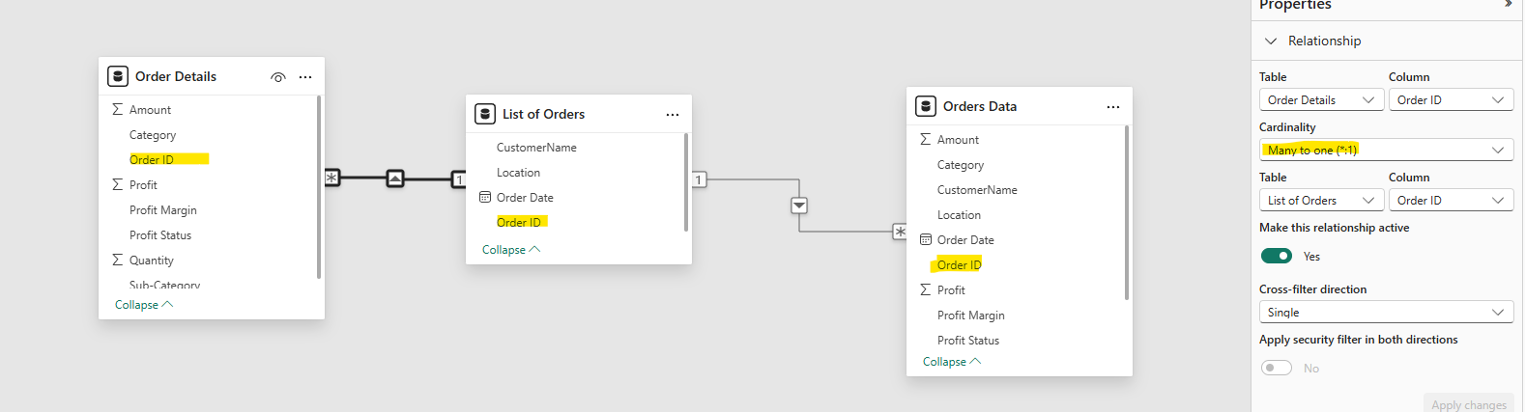

17.Build a relationship between the “Order Details” and “Sales Target” tables based on the ‘Category’ column. Click "Manage relationships" and ensure this relationship is active.

